**EXPERIMENT 4: MAP-REDUCE PROGRAM**

Name: Sunayana M

USN: 1NT19IS165

Batch : C2

Program:

package sunayana;

import java.io.IOException;

import java.util.*;

import org.apache.hadoop.fs.Path;

import org.apache.hadoop.io.*;

import org.apache.hadoop.mapred.*;

public class transactionCount {

//MAPPER CODE

public static class Map extends MapReduceBase implements

Mapper<LongWritable, Text, Text, IntWritable> {

private final static IntWritable one = new IntWritable(1);

//private Text word = new Text();

public void map(LongWritable key, Text value, OutputCollector<Text,

IntWritable> output, Reporter reporter) throws IOException {

String myString = value.toString();

String[] userCount = myString.split(",");

output.collect(new Text(userCount[3]), one);

}

}

//REDUCER CODE

public static class Reduce extends MapReduceBase implements

Reducer<Text, IntWritable, Text, IntWritable> {

public void reduce(Text key, Iterator<IntWritable> values,

OutputCollector<Text, IntWritable> output, Reporter reporter) throws

IOException { //{little: {1,1}}

int finaluserCount = 0 ;

Text mykey = key ;

while(values.hasNext()) {

IntWritable value = values.next();

finaluserCount += value.get();

}

output.collect(mykey, new IntWritable(finaluserCount));

}

}

//DRIVER CODE

public static void main(String[] args) throws Exception {

JobConf conf = new JobConf(transactionCount.class);

conf.setJobName("transactioncount");

conf.setOutputKeyClass(Text.class);

conf.setOutputValueClass(IntWritable.class);

conf.setMapperClass(Map.class);

conf.setCombinerClass(Reduce.class);

conf.setReducerClass(Reduce.class);

conf.setInputFormat(TextInputFormat.class);

conf.setOutputFormat(TextOutputFormat.class);

FileInputFormat.setInputPaths(conf, new Path(args[0]));

FileOutputFormat.setOutputPath(conf, new Path(args[1]));

JobClient.runJob(conf);

}

}

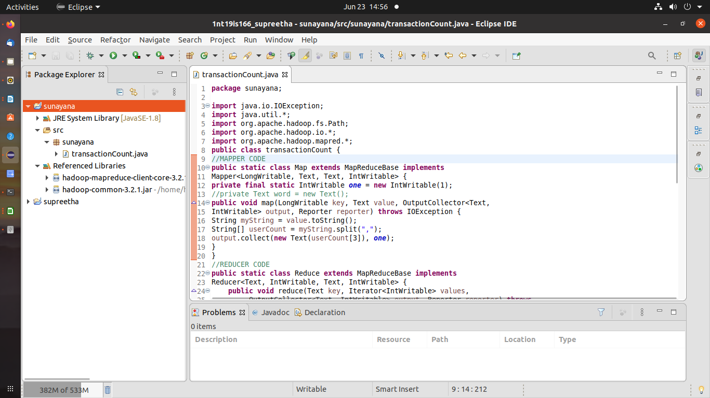

.csv File:

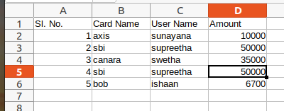

Commands:

$ cd $HADOOP_HOME

$ cd sbin

$ ./start-all.sh



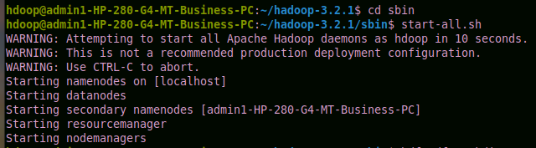

hdfs dfs -mkdir -p /sunayana

hdfs dfs -copyFromLocal /home/hdoop/Desktop/sunayana.csv /sunayana



hadoop jar /home/hdoop/Desktop/sunayana.jar /sunayana /sunayana_op

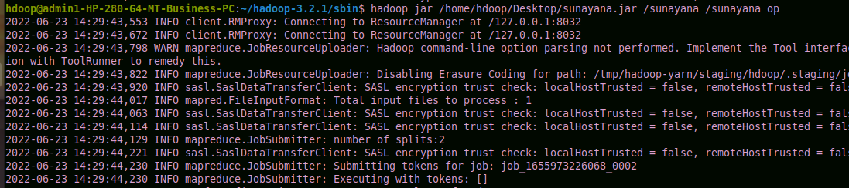

hdfs dfs -cat /sunayana_op/part*

